How to check computer name

**Sample**

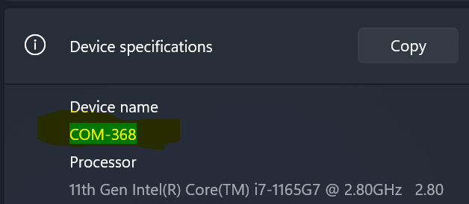

Ex. This computer name is **COM-368**

**Method 1**

Go to your Desktop then right click on **This PC** and then click on **Properties**

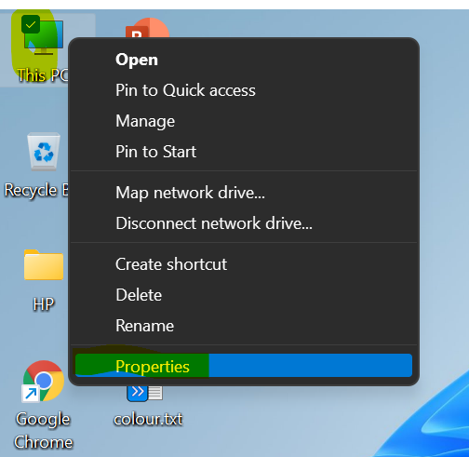

You will see your computer name as **Sample** above

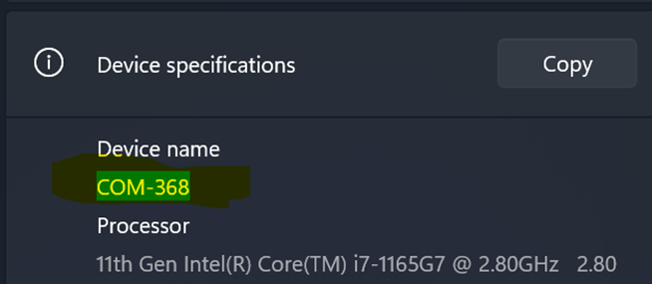

If you cannot find **This PC** on your computer screen, please go to **method 2**

**Method 2**

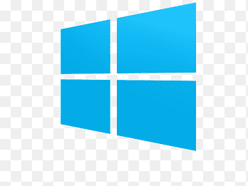Open your **File Explorer** by pressing **Windows** key + **E**

Go to **This PC** tab then right click on it and then click on **Properties**

You will see your computer name as **Sample** above

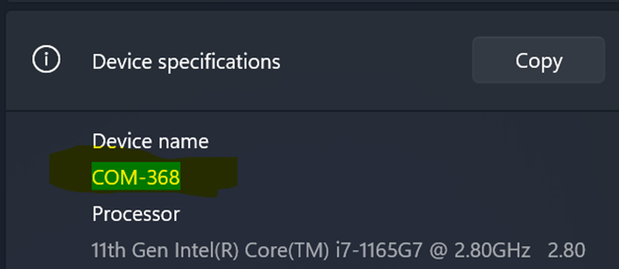

**Finish**